Experiment No. 13
Implementation of Minimax Algorithm for Gaming
Question: Write a Python program to implement the Minimax algorithm for a Tic-Tac-Toe game.
Aim: To implement the Minimax algorithm to determine the optimal move for a computer player in a two-player game.
Algorithm:
- Start the program.
- Initialize the game board.
- Check whether the current game state is a win, loss, or draw.
- Assign scores to terminal states: +1 for a computer win, -1 for a human win, and 0 for a draw.
- Generate all possible legal moves.
- If it is the maximizing player's turn, select the maximum score.
- If it is the minimizing player's turn, select the minimum score.
- Recursively evaluate possible moves using the Minimax algorithm.
- Choose the best move for the computer.
- Repeat until the game ends.
- Display the result and stop the program.
Code:
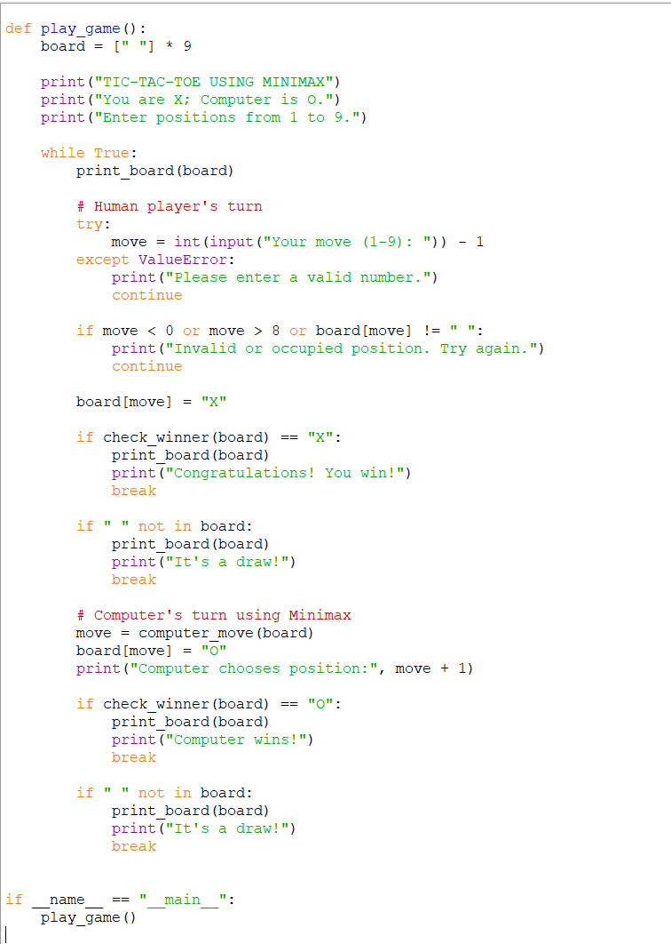

Output:
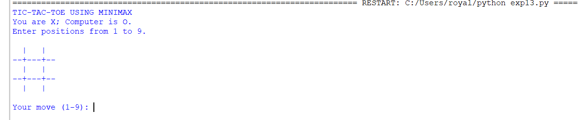

Result: The Minimax algorithm was successfully implemented in Python to select the optimal move for the computer in the Tic-Tac-Toe game.

